Nepal College of Information Technology
Unit Test
Fall 2013
Program : BE CE/ELX Time : 2 hrs
Semester : (III) FM : 70
Subject : Network Theory PM : 35

- Candidates are requested to give their answer as far as practicable in their own words.
- The figure in the margin indicates the full marks
- Attempt ALL question

1 a) The circuit shown in figure has been in steady state for a long time with the switch ‘S’ open. Determine the complete solution for the current when ‘S’ is closed. Use classical approach. 8
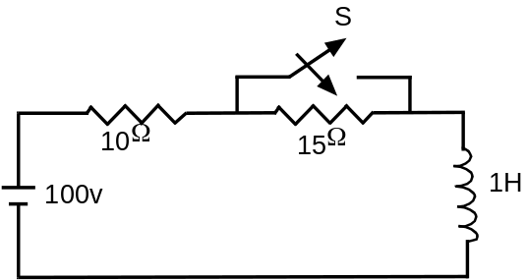
b) The switch K is transferred from position 1 to 2 at t =0+, in the given circuit. Find the value of i(0+),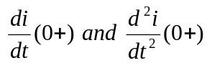 at t = 0+, if the steady state condition is reached before transferring the switch. 7
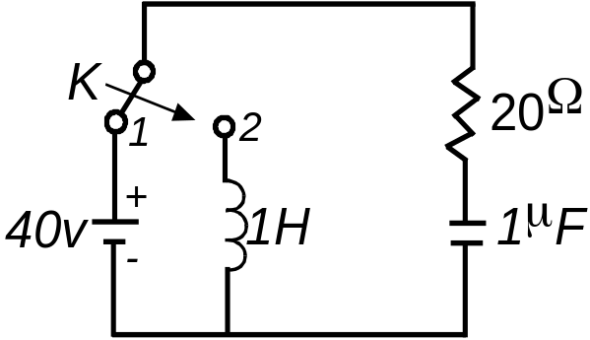
2 a) In the series R-C circuit, the applied voltage is v(t) = 5 sin(10⁵t + 30⁰ ), R= 1Ω and C=0.1 µF. Obtain the particular solution for current i(t) through the circuit. Switch k is closed at time t=0. Assume zero initial charge across the capacitor C. 8
b) Determine the solution for the current differential equation, i”(t)+3i’(t)+2i(t)=4e^{t}, initial conditions i(0+)=1, i'(0+)= -1. Use classical method. 7
3 a) In the parallel R-L-C circuit, C=1F, R=1/6 Ω, L= 1/9 H and I₀ = 4 A. Switch k is opened at time t=0. Obtain the particular solution for v(t). Calculate the value of voltage v at t=0.1 sec and 0.2 sec. 8
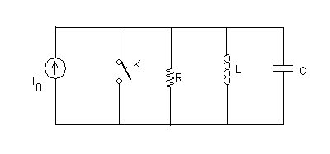
b) In the given circuit switch 'K' is closed at t=0, find 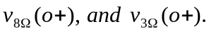 7
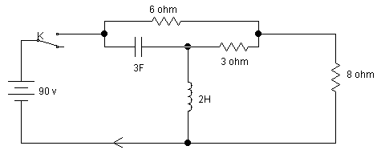

4) Derive an expression for current i(t) for second order network consisting of resistance R inductance L Henry and capacitance C Farad when a step voltage of V volts is applied at time t = 0. Determine the natural frequency and damping coefficient of the network. Also sketch i(t). 12
5 a) An exponential supply 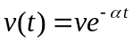 is suddenly applied to a series circuit containing resistor R and inductor L. Find the expression of i(t) at any time using classical method. 8
b) What are the advantages of Laplace transform over classical approach. 5

